Anomaly

Detection

What is Anomaly Detection?
Anomaly detection aims to distinguish these unusual patterns or outliers from the normal patterns in the data.
- Normal patterns in data represent the typical behaviour or expected outcomes based on historical data or established norms. These patterns may include common trends, distributions, relationships, or characteristics observed in the majority of the data.
- Unusual patterns, also known as anomalies or outliers, are data points or instances that do not conform to the normal patterns observed in the data. Anomalies can
manifest in various forms, such as extreme values, unexpected patterns, irregularities, or rare occurrences.
- The goal of anomaly detection is to distinguish these unusual patterns or outliers from the normal patterns in the data. This involves identifying data points or instances that deviate significantly from the expected behaviour or distribution of the data.

Anomaly Detection in Kibana
- In Kibana, the anomaly detection feature is part of the Machine Learning (ML) capabilities provided by the Elastic Stack. It allows users to detect anomalies and unusual patterns in their data using machine learning algorithms without requiring advanced data science expertise. When performing anomaly detection in Kibana, you typically create an anomaly detection job to initiate the analysis process. An anomaly detection job in Kibana is a configuration setting that specifies the parameters and criteria for analysing data to detect anomalies. It encapsulates the entire process of anomaly detection, from data ingestion to model training and anomaly identification.

- The basic requirement is that the data used for anomaly detection should be time-based means that the data contains timestamps or time-related information associated with each data point. Time-based data often exhibits temporal patterns, trends, and seasonality that evolve over time. These patterns may include daily, weekly, monthly, or yearly variations in the data, such as periodic fluctuations, trends, or recurring events. Analysing these temporal patterns helps identify normal behaviour and deviations from the expected patterns, which are indicative of anomalies.

Creating a job for Anomaly Detection

Dataset
The dataset which we are using is the Atlanta crime dataset. The Atlanta crime dataset contains information about various crimes reported in the city of Atlanta. Here’s an elaboration on each of the seven columns in the dataset:
  - Crime: This column represents the type or category of crime that occurred. It may include offenses such as theft, burglary, assault, robbery, vandalism, etc.

  - Date: The date column indicates the date when the crime occurred. It provides a temporal context for each crime incident, allowing analysts to analyse the patterns and trends of crimes over time.

  - Location: This column describes the address where the crime took place.

  - Beat: The beat column refers to the police beat or patrol zone where the crime occurred. Police beats are predefined geographical areas assigned to law enforcement officers for patrolling and crime prevention purposes. Analysing crime incidents by beat can help identify high-crime areas or patterns of criminal activity within specific patrol zones.

  - Neighbourhood: This column specifies the neighbourhood or district within Atlanta where the crime occurred.

  - Latitude: The latitude column contains the geographical latitude coordinates of the crime location.

  - Longitude: The longitude column contains the geographical longitude coordinates of the crime location.

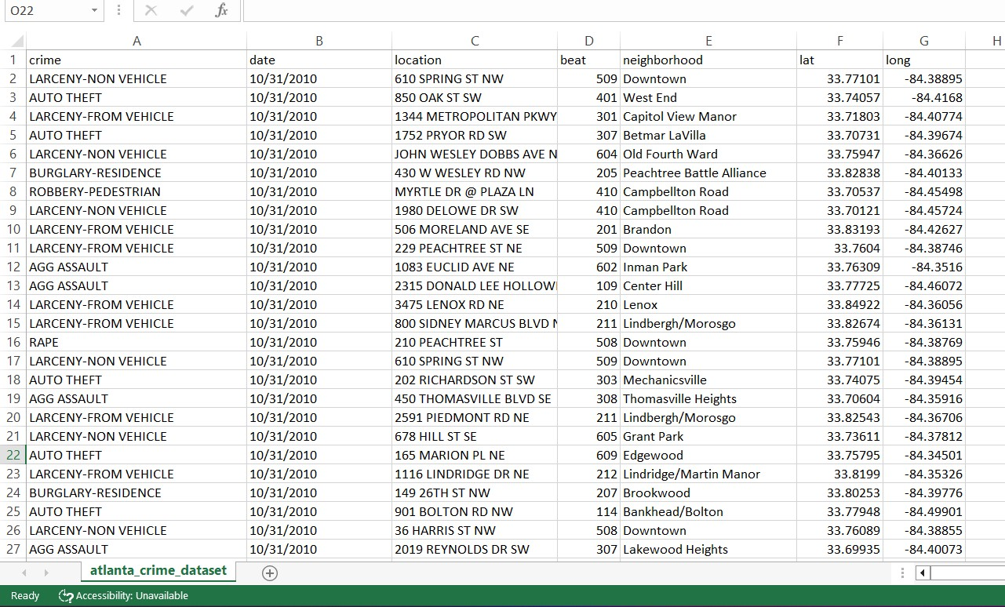
To perform anomaly detection on the Atlanta crime dataset in Kibana, you first need to upload the dataset into Elasticsearch, which is the underlying data store used by Kibana. Once the data is uploaded, you can create a data view, also known as an index pattern, to define how the data should be indexed and queried in Kibana.

Creating a Job
After creating the data view (index pattern) in Kibana, the next step is to set up a job for anomaly detection. A job in anomaly detection is a configuration that defines the parameters and criteria for analysing the data to detect anomalies. Follow the following steps:
- To perform anomaly detection, navigate to the "Machine Learning" section in Kibana. Click on "Create job"

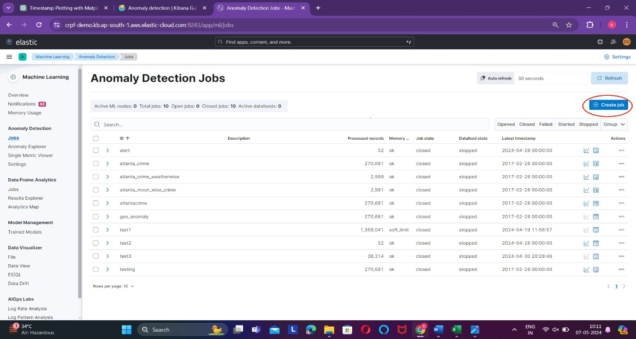

- Select the data view on which we are going to perform anomaly detection
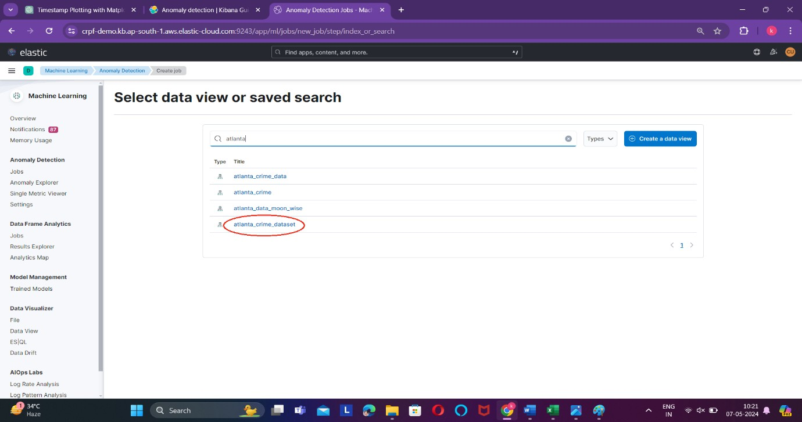

- Select the appropriate job type based on your analysis requirements.
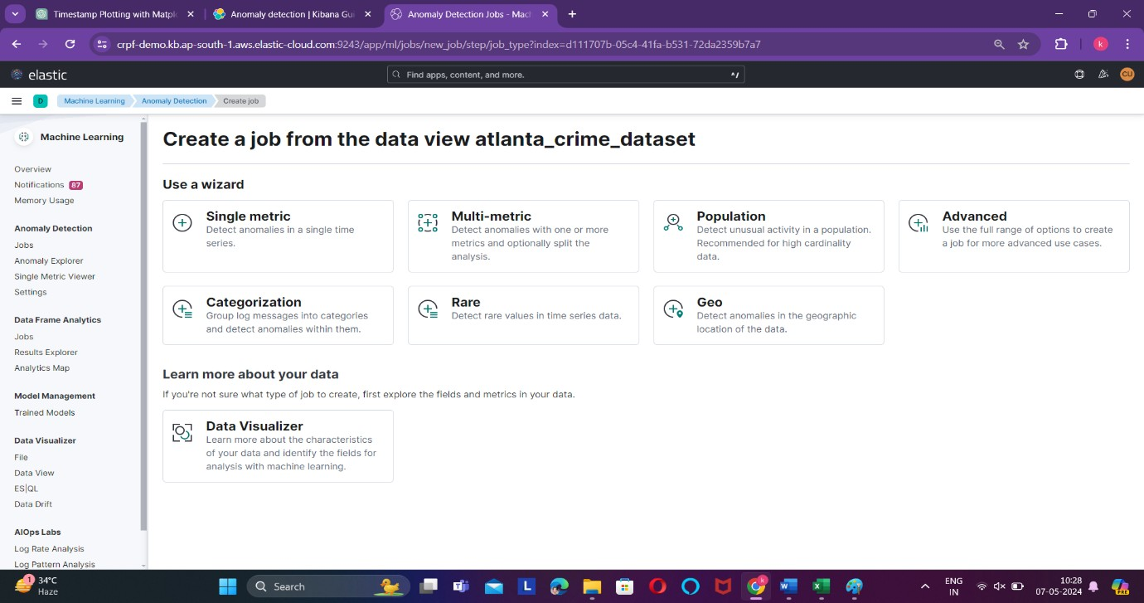
- Single Metric: The single metric wizard creates simple jobs that have a single detector. A detector applies an analytical function to specific fields in your data. In addition to limiting the number of detectors, the single metric wizard omits many of the more advanced configuration options. The Single Metric wizard in Kibana's anomaly detection is specifically designed for detecting anomalies in a single numerical column or metric over time.
- Multi-Metric: The multi-metric wizard creates jobs that can have more than one detector, which is more efficient than running multiple jobs against the same data. The multi-metric wizard in Kibana's anomaly detection is specifically designed for detecting anomalies in multiple columns or metrics simultaneously.
- Population: The population wizard creates jobs that detect activity that is unusual compared to the behaviour of the population. The Population wizard in Kibana's anomaly detection feature is used when you want to analyse population-level data and detect anomalies in aggregated metrics. It's particularly useful in scenarios where you're interested in understanding how anomalies in a metric relate to changes in the size or count of a population over time
- Advanced: The advanced wizard creates jobs that can have multiple detectors and enables you to configure all job settings. Advanced Configuration wizard in Kibana's anomaly detection feature caters to users who require more control and flexibility over the settings and parameters of the anomaly detection job. It enables advanced customization of algorithm parameters, feature selection, model interpretability, outlier handling, and integration with external data sources to address complex use cases and achieve optimal performance in anomaly detection analyses.
- Categorization: The categorization wizard creates jobs that group log messages into categories and use count or rare functions to detect anomalies within them. categorization is used in anomaly detection to incorporate categorical variables into the analysis, group data points based on categories, compare behaviour across different groups, perform hierarchical analysis, and customize alerts and notifications based on specific categories of interest. This enables more contextually rich and targeted

anomaly detection analyses tailored to the unique characteristics of your dataset and use case.
- Rare: The Rare wizard in anomaly detection acts as a spotlight, shining a light on the rare and unusual aspects of your data. It helps you uncover hidden insights, identify potential issues or opportunities, and prioritize your attention where it matters most.
- Geo: The Geo wizard in anomaly detection is used when you want to analyse data with geographic components and detect anomalies in the spatial distribution of those data points. It enables you to identify unusual patterns or deviations in the geographic distribution of events, phenomena, or assets, helping you make informed decisions and take appropriate actions based on the spatial context of your data.

To analyse anomalies in the Atlanta crime dataset, we'll leverage the multi-metric wizard. This tool allows us to investigate multiple aspects of the data simultaneously, providing a comprehensive understanding of potential irregularities across various crime-related metrics.
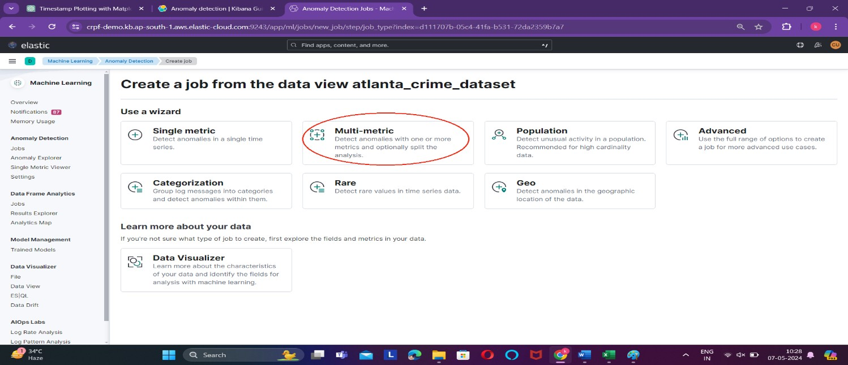

- To utilize the complete dataset from the data view we've created, you can select "Use Full Data" to include all available data points. Alternatively, you have the option to specify a specific time range for the anomaly detection analysis if you're interested in investigating anomalies within a particular timeframe.
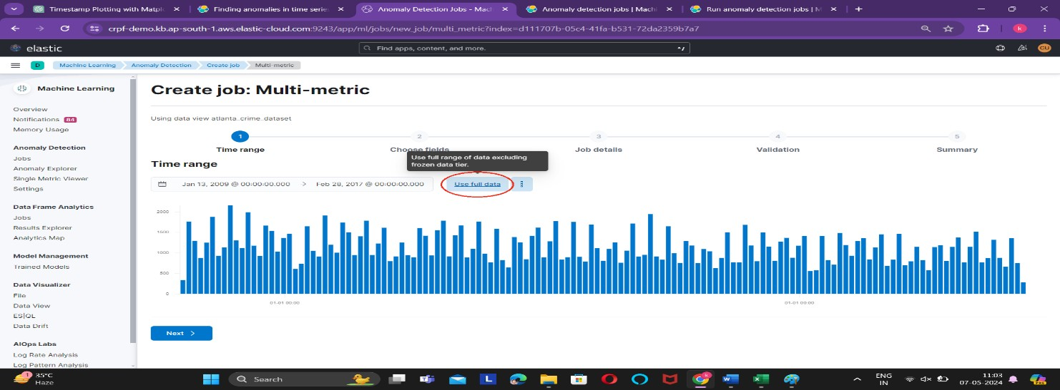

- Now, we need to choose the detectors that will be used to identify anomalies in the data. These detectors are the specific metrics or characteristics that we'll monitor for unusual patterns or deviations from the expected behaviour.
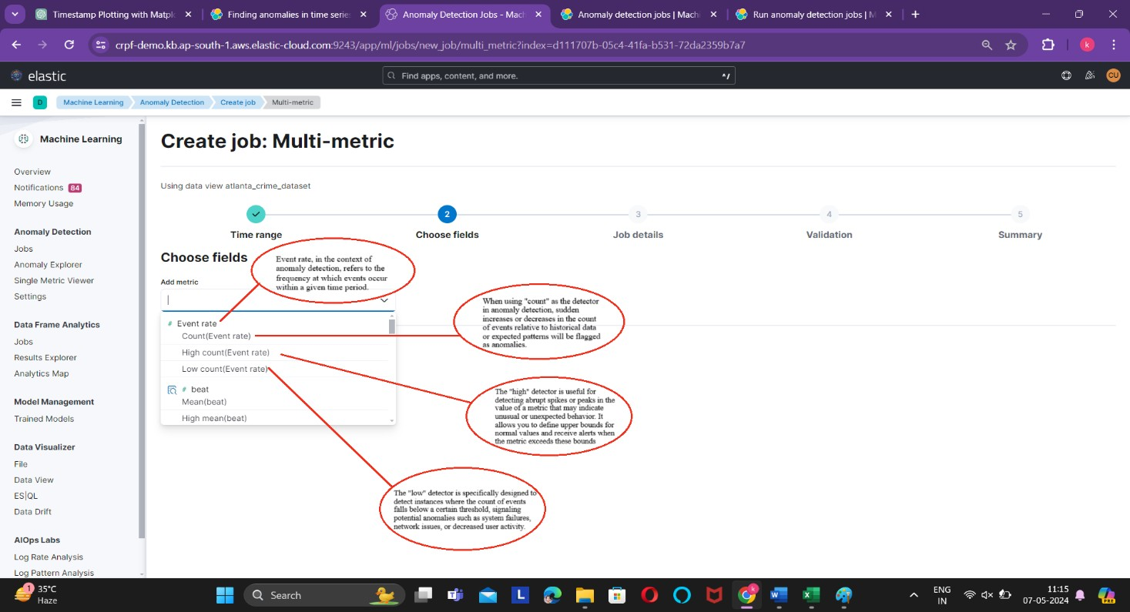

In our selection, we've opted for the "high event count" detector, aiming to pinpoint sudden spikes in crime occurrences. This choice enables us to focus on detecting significant increases in the count of criminal activities within the dataset.

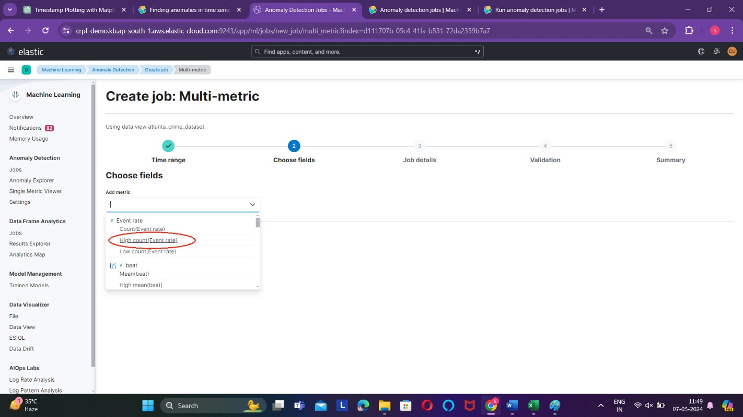

- The "split field" option in anomaly detection allows you to segment your data based on a categorical or discrete field. By selecting a split field, you can analyse and compare anomalies within different segments or categories of your data.

In this case, we're utilizing the "split field" option to segment the data based on neighbourhoods. By doing so, we aim to examine anomalies in crime occurrences within each neighbourhood individually. This segmentation allows for a more granular analysis, enabling us to detect and understand patterns of anomalies specific to each neighbourhood’s crime activity.
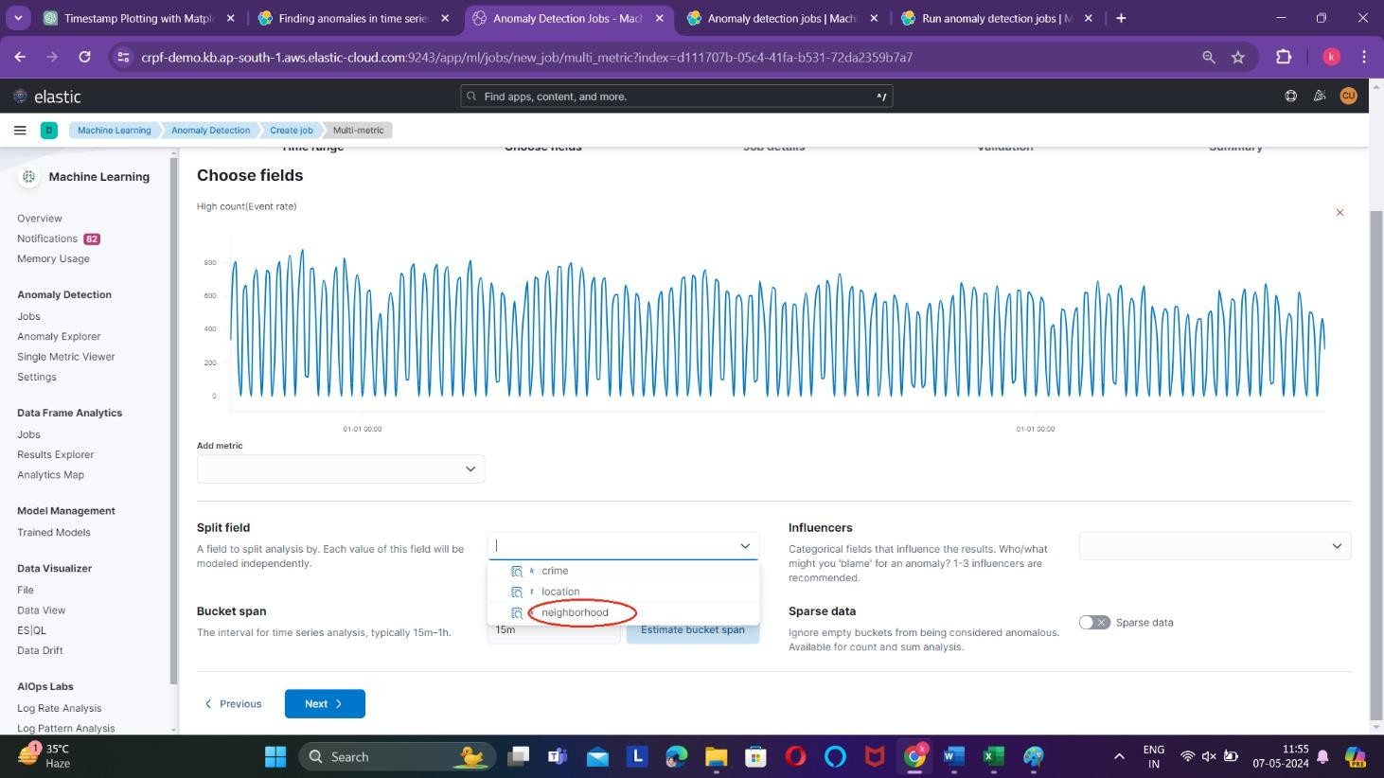

- Now we select the influencers.
When anomalous events occur, we want to know why. To determine the cause, however, you often need a broader knowledge of the domain. If you have suspicions about which entities in your data set are likely causing irregularities, you can identify them as influencers in your anomaly detection jobs. That is to say, influencers are fields that you suspect contain information about someone or something that influences or contributes to anomalies in your data. Influencers can be any field in your data.

In our selection, we're choosing "neighbourhood" and "crime" as influencers, recognizing the possibility of anomalies arising from increased crime rates in specific neighbourhoods or specific types of crimes occurring more frequently. This decision enables us to investigate anomalies attributed to changes in crime patterns within neighbourhoods or to particular crime categories, providing deeper insights into the factors driving anomalous behaviour.

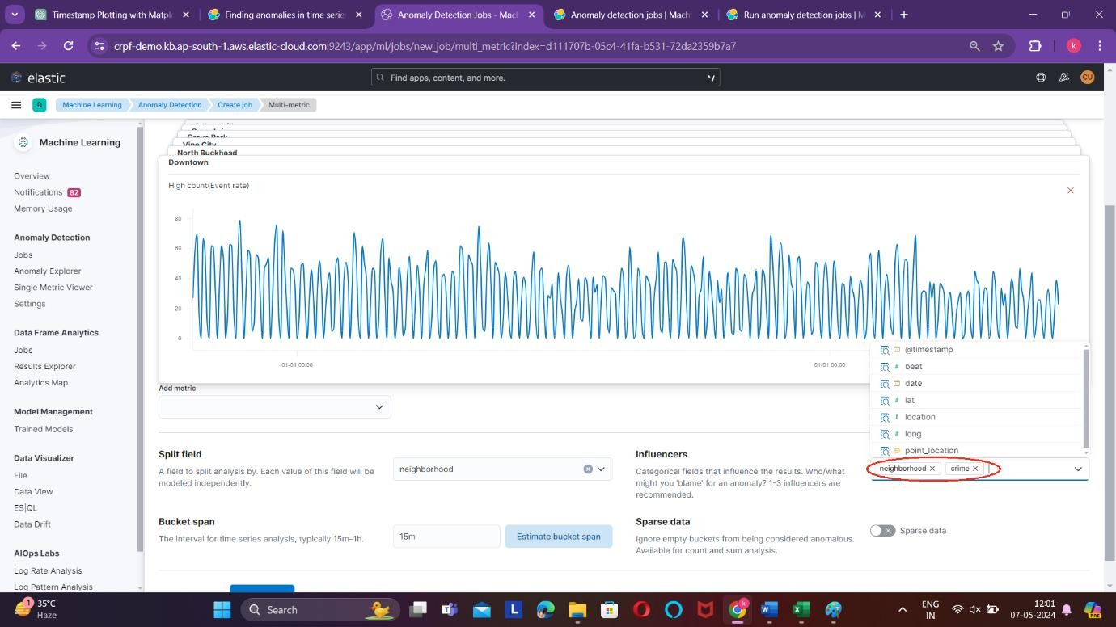

- Now select the bucket span. The machine learning features use the concept of a bucket to divide the time series into batches for processing.
The bucket span is part of the configuration information for an anomaly detection job. It defines the time interval that is used to summarize and model the data. This is typically between 15 minutes to 1 hour and it depends on your data characteristics. When you set the bucket span, take into account the granularity at which you want to analyse, the frequency of the input data, the typical duration of the anomalies, and the frequency at which alerting is required.
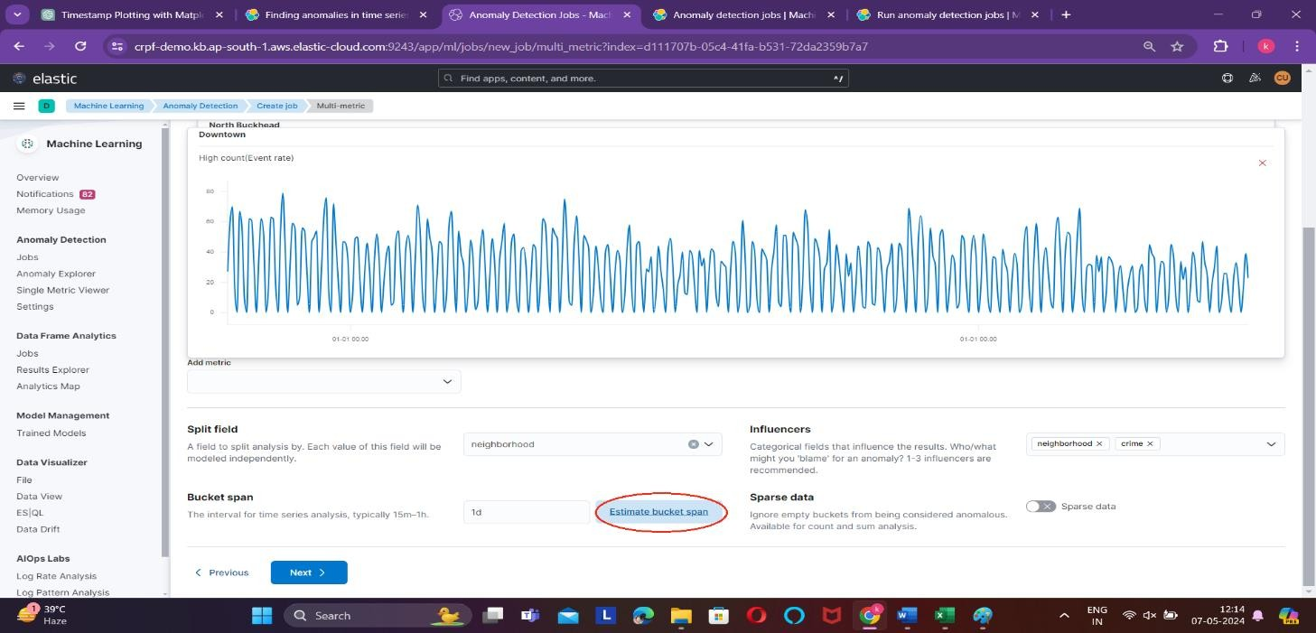
When you create an anomaly detection job in Kibana, you can choose to estimate a bucket span value based on your data characteristics.

- Now enable the sparse data option.
When the "sparse data" option is enabled, the algorithm adjusts its anomaly detection process to appropriately weigh the available data points relative to the overall data density. It helps prevent false alarms or inaccuracies in anomaly detection that may arise from gaps in the data, ensuring that anomalies are accurately identified even in sparse regions of the dataset.
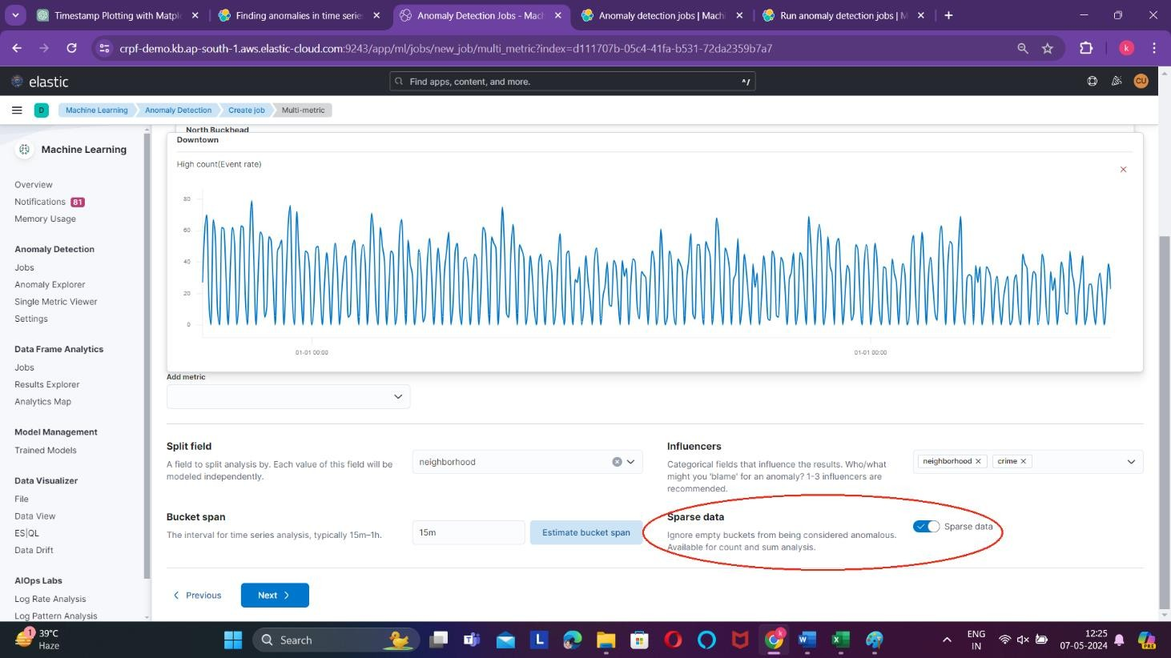

- Give your job an ID.
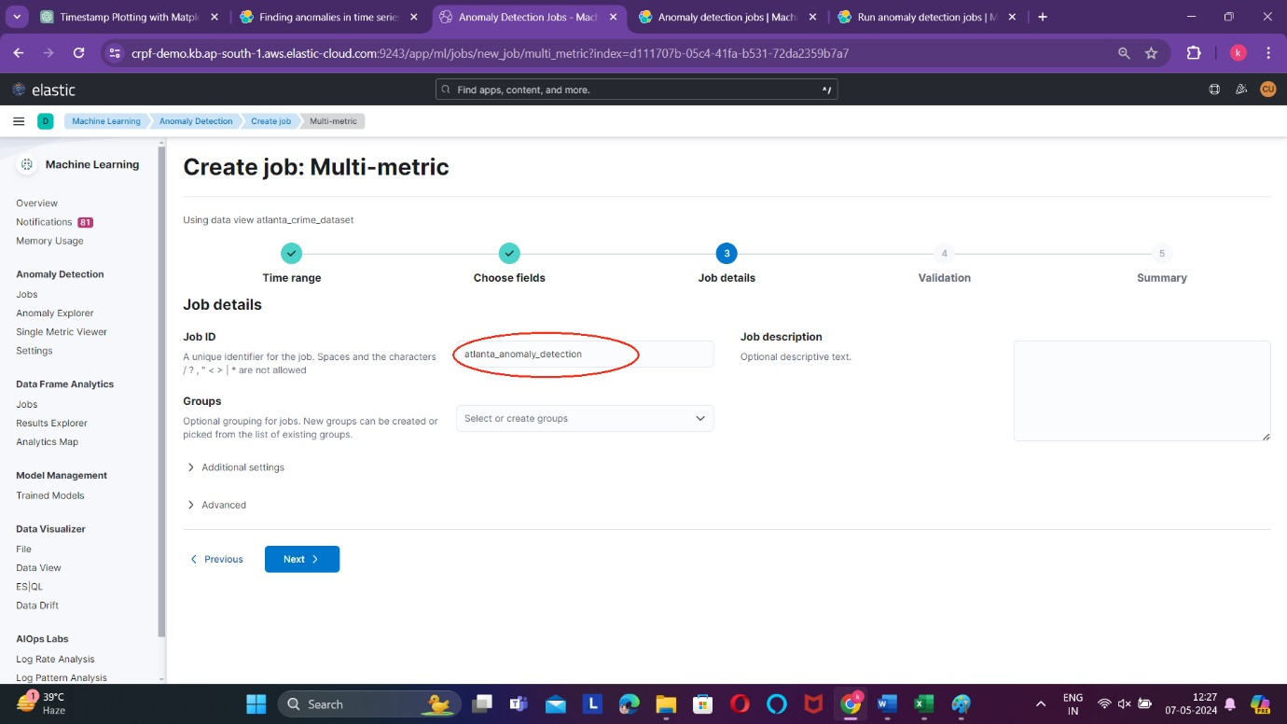

- To initiate the creation of the anomaly detection job with the configured settings, simply click on the "Create Job" button. This action will trigger the job creation process, during which the system will generate the anomaly detection job based on the specified configuration parameters. Once the job is successfully created, it will start analysing the data according to the defined settings, allowing you to monitor anomalies and receive alerts as necessary.

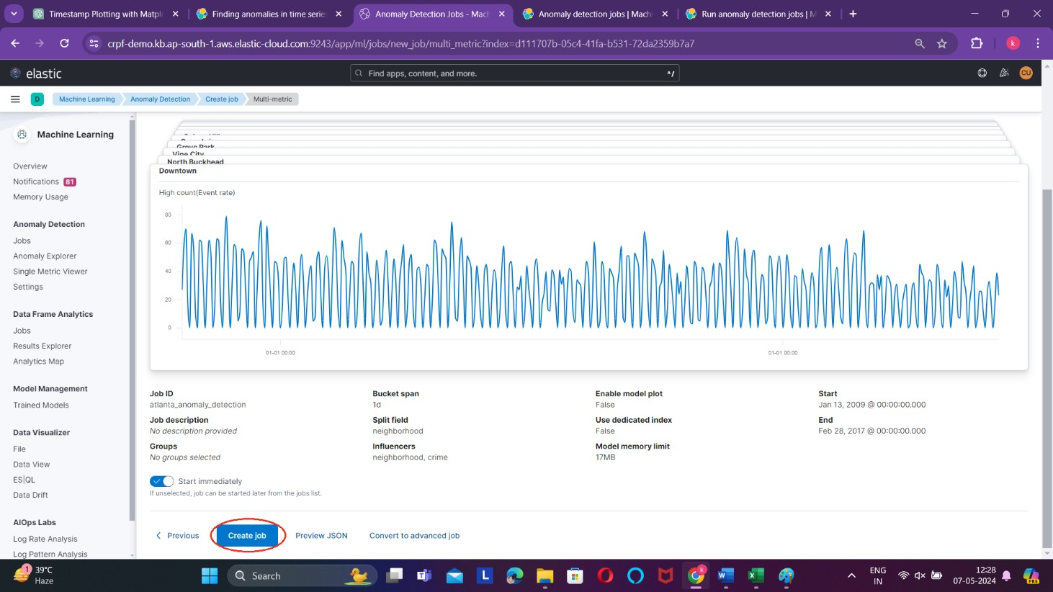

Now that the job has been successfully created, you can proceed to view the results to identify anomalies in the data. By analysing the output, you can pinpoint instances of sudden increases in crime occurrences and delve deeper into the underlying causes or patterns driving these anomalies within the dataset.

Anomaly Explorer
With the Anomaly Explorer tool, you can effectively visualize and explore the anomalies detected by the job we've created. This feature enables you to gain insights into the anomalous patterns present in the data, including sudden increases in crime occurrences or other unusual trends. By utilizing the Anomaly Explorer, you can efficiently navigate through the anomalies, understand their significance, and take appropriate actions based on the insights gleaned from the analysis.
In our dataset, the Anomaly Explorer allows us to pinpoint spikes in crime occurrences across different neighbourhoods. By visualizing the data, we can identify specific areas experiencing sudden increases in criminal activity. This insight helps prioritize resource allocation and intervention strategies, enabling proactive measures to address crime hotspots and maintain community safety effectively.

Exploring the Results of the Job
Here the anomaly is being detected neighbourhood wise.
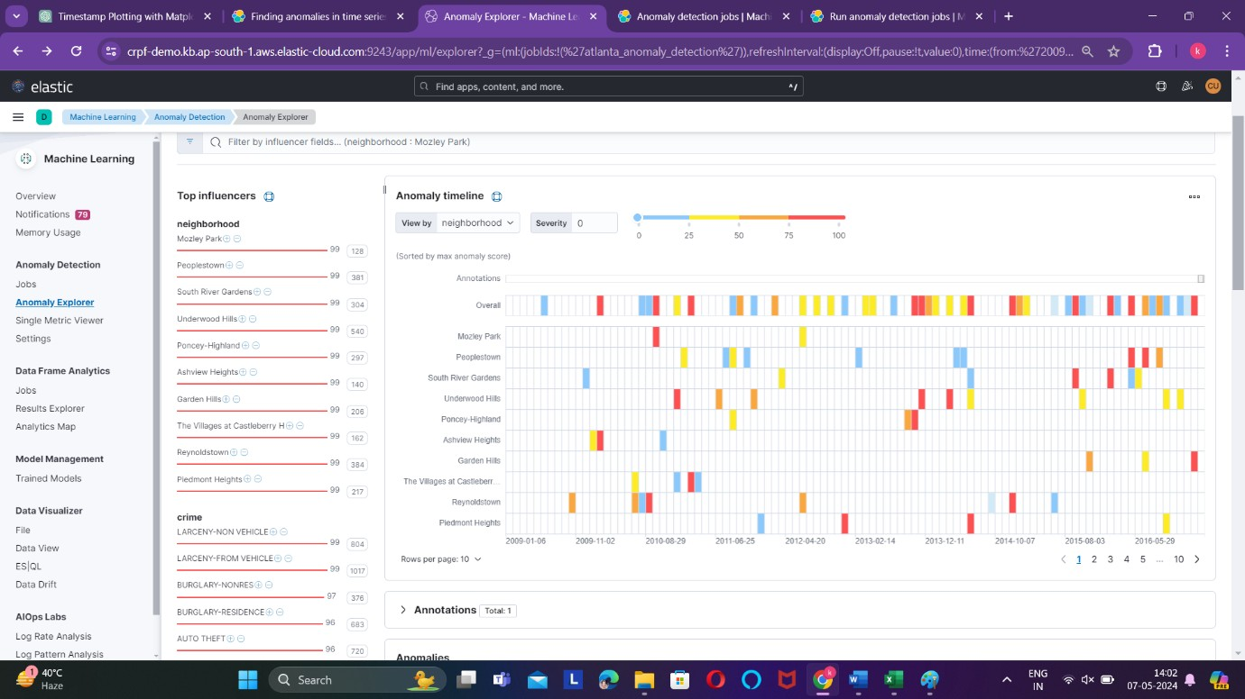

Let us understand the result:
Severity: Every anomaly is assigned an anomaly score, which reflects its severity or significance. This score quantifies the abnormality of the observed behaviour, helping prioritize responses based on the level of urgency. Higher anomaly scores indicate more severe anomalies requiring immediate attention, while lower scores signify less critical deviations that may warrant further monitoring or investigation.
The anomaly score is utilized to define the severity of anomalies, with color-coded representations indicating their significance. Typically, a colour gradient ranging from blue to red is employed, where blue denotes anomalies with the lowest severity and red signifies

anomalies of the highest severity. This visual representation aids in quickly identifying and prioritizing anomalies based on their level of urgency or impact.
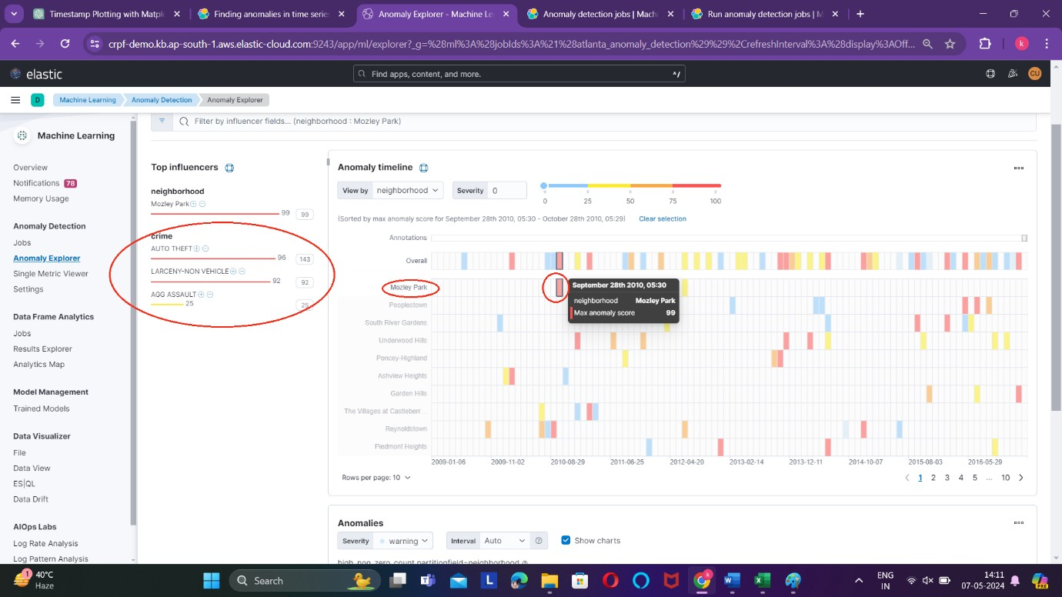
By clicking on a specific anomaly, such as the sudden increase in crime in Mozley Park on September 28th, 2010, you can access detailed information about the event. This includes the types of crimes involved, such as auto-theft, larceny non-vehicle, and aggravated assault. This level of detail allows for a deeper understanding of the anomaly and facilitates informed decision-making regarding intervention strategies or resource allocation in the affected area.

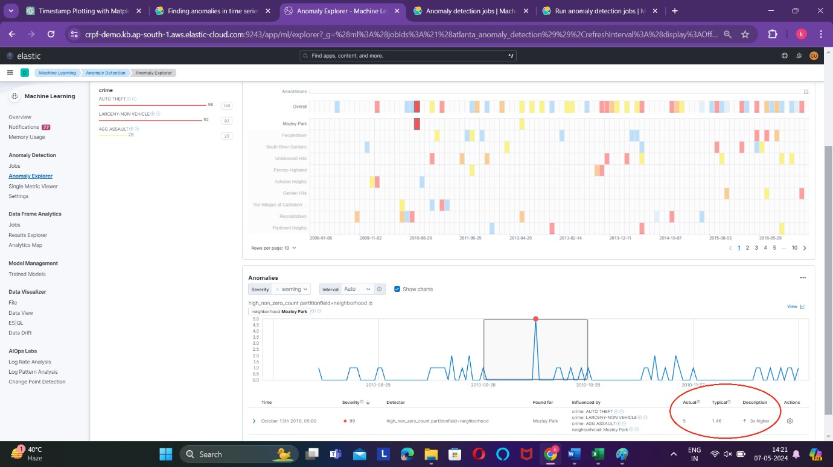

This anomaly occurred because generally rate was 1.4 but on that particular day the crime rate was 5 i.e. the crime rate increased by 3 times. Now using the previous data of this neighbourhood, we can predict the number of crimes that can take place in next 10 years.

Forecasting
In forecasting, the Single Metric Viewer is commonly used to analyse and predict future trends based on historical data for a single metric or variable. This viewer provides visualization tools and forecasting algorithms to model the behaviour of the selected metric over time, allowing users to generate forecasts and make informed decisions based on projected trends.
To initiate the forecasting process, simply click on the "View" option within the Single Metric Viewer. This action will allow you to access the forecasting tools and functionalities available within the viewer, enabling you to analyse historical data, generate forecasts, and gain insights into future trends for the selected metric.
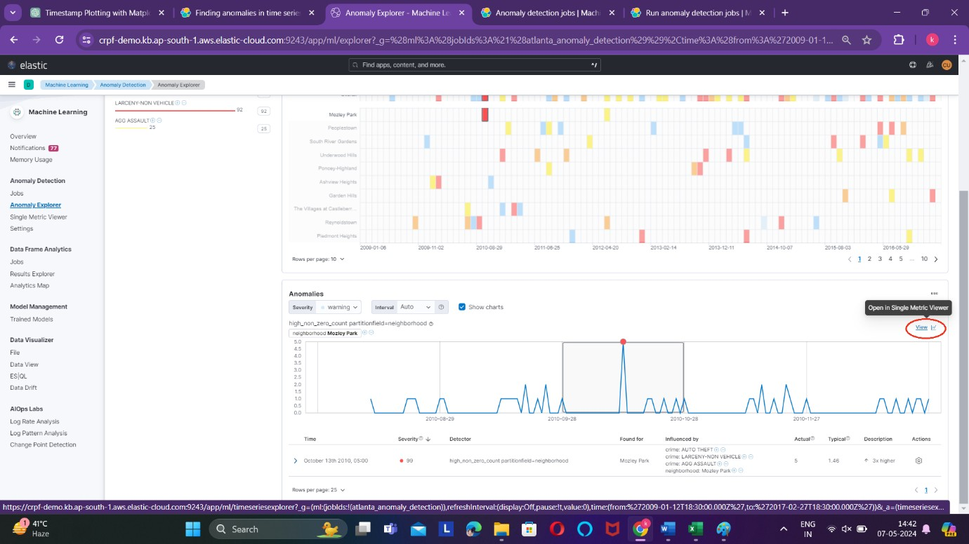

Upon clicking the "View" option, your data will be displayed within the Single Metric Viewer interface. Here, you can explore various visualization tools and forecasting capabilities to analyse the historical trends of the selected metric and generate forecasts for future time periods. This viewer provides an intuitive platform for conducting in-depth analysis and gaining insights into the behaviour of the metric over time.

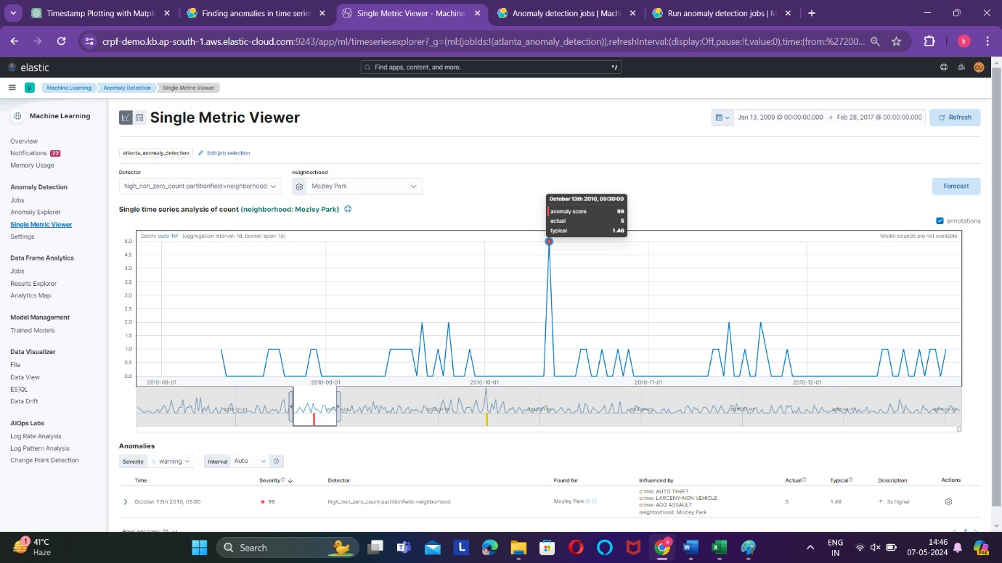

In the Single Metric Viewer, the y-axis typically represents the metric of interest, such as crime rate or event rate, while the x-axis represents time.
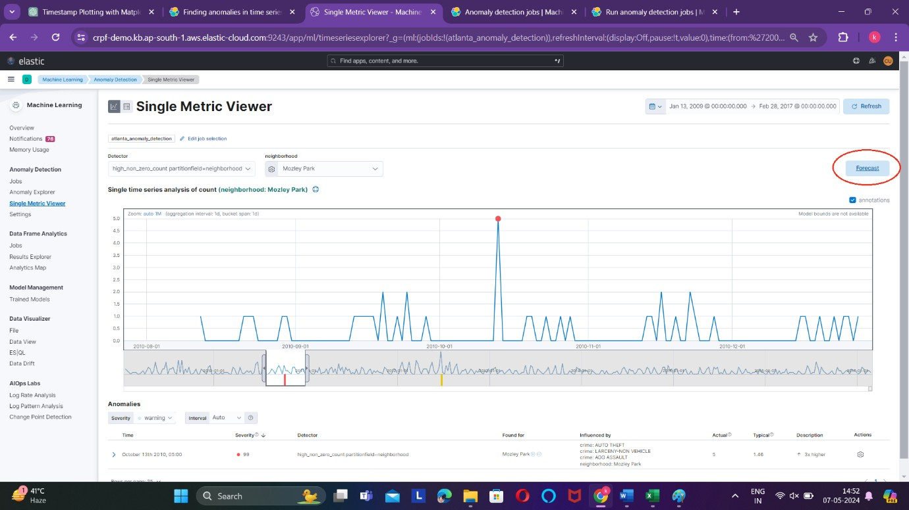

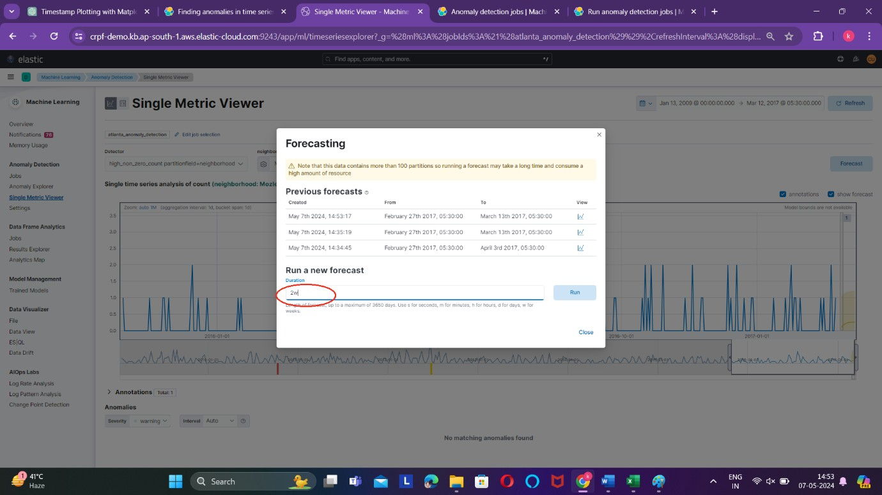

Let’s forecast the crime rate in Mozley park in next 2 weeks. The result of forecasting is given below
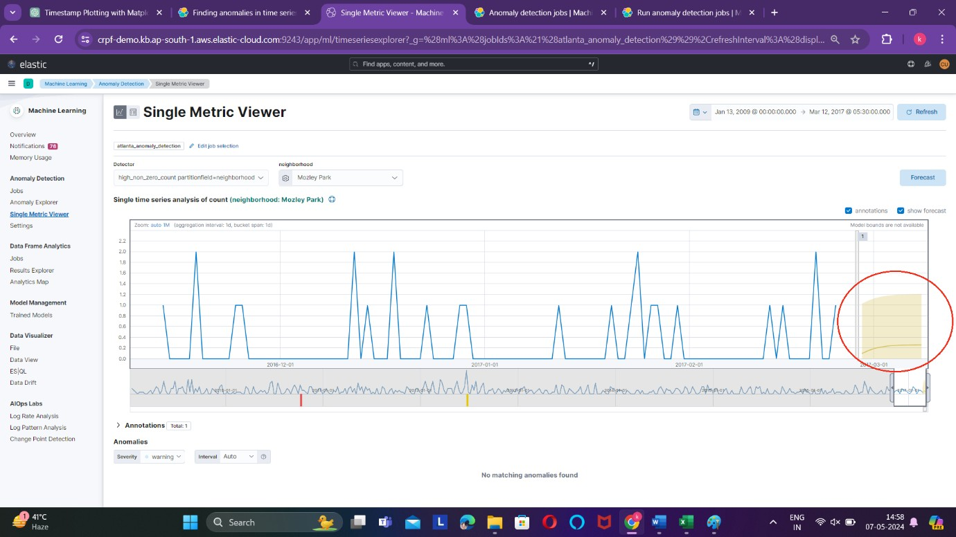
In the visualization, the yellow portion represents the predicted crime rate for Mozley Park over the next two weeks. This prediction is generated by the forecasting model based on historical data and trends observed in the crime rate metric.
When you hover your cursor over the yellow line representing the predicted crime rate, the Single Metric Viewer will display a tooltip showing the predicted crime rate for that specific point in time, along with the corresponding date.

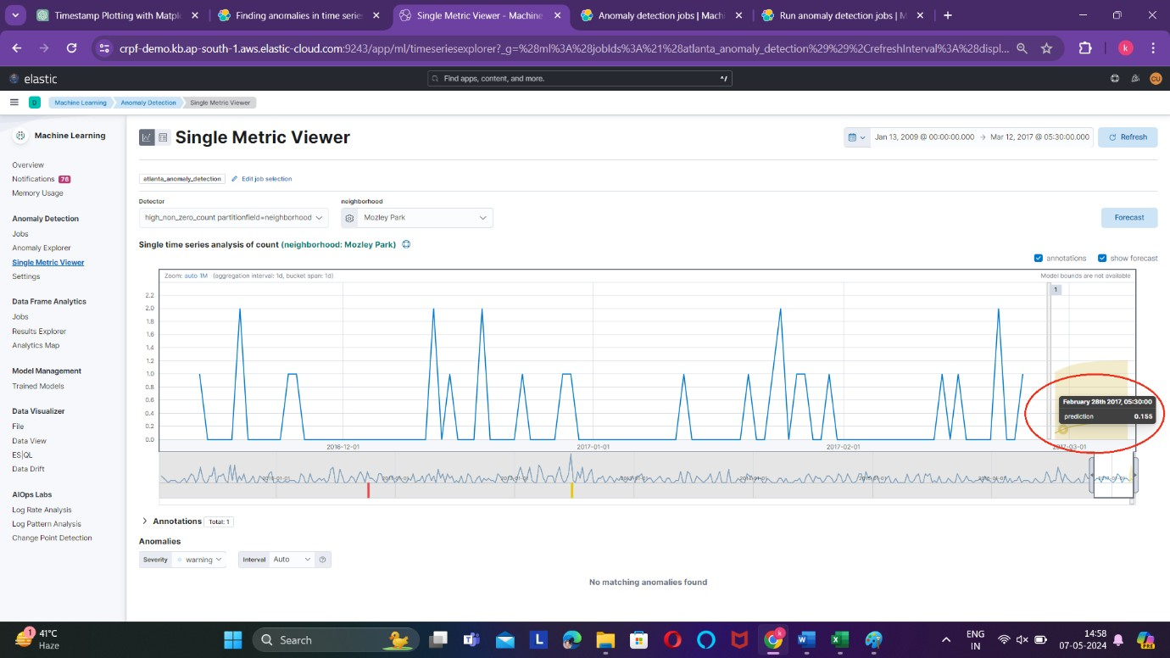

By selecting different neighbourhoods within the dataset, you can generate forecasts for their respective crime rates over future time periods. For Example, by selecting "West End" as the neighbourhood of interest within the dataset, you can utilize the forecasting capabilities of the Single Metric Viewer to generate predictions for the crime rate in the West End area over the next two weeks.
